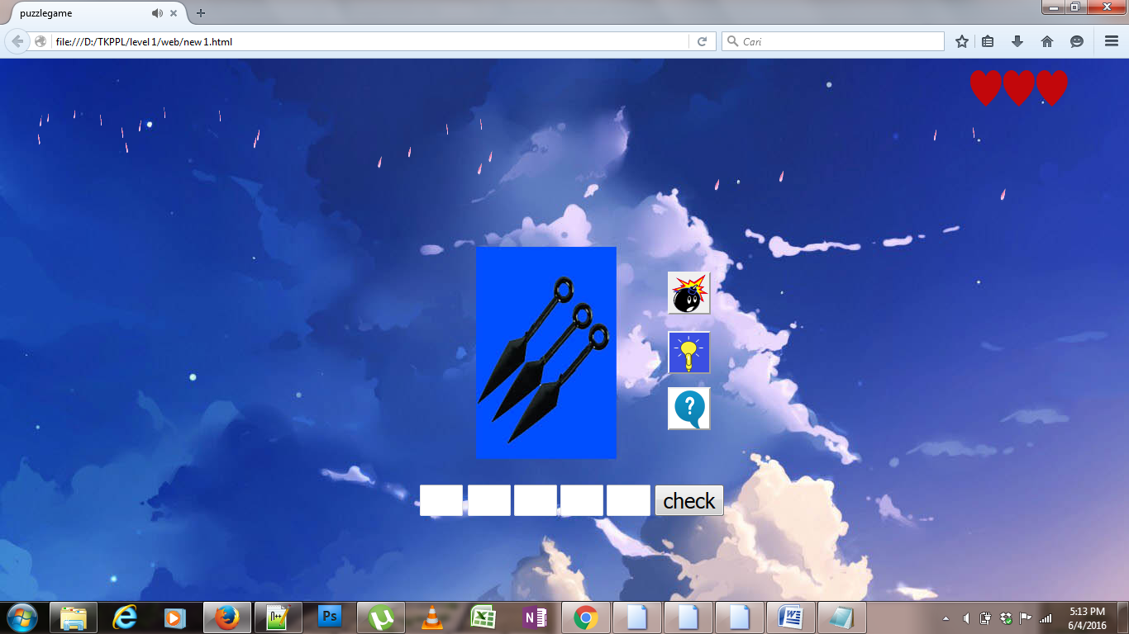

<html>

<title>puzzlegame</title>

<head>

<style type="text/css">

.st{

margin:20px;

margin-top:50px;

margin-left:500px;

font-size:25;

}

.du{

margin-left:-18px;

font-size:25;

}

.ti{

font-size:25;

}

.em{

font-size:25;

}

.li{

font-size:25;

}

.love{

width:50px;

height:50px;

margin-left:1160px;

}

.love1{

width:50px;

height:50px;

margin-left:1200px;

margin-top:-50px;

}

.love2{

width:50px;

height:50px;

margin-left:1240px;

margin-top:-50px;

}

.sz{

font-size:25;

}

.unit{

animation:snow 20s infinite;

position:absolute;

top:-10px;

display:block;

}

@keyframes snow{

from{top:-10px;left:1200px;transform:rotatey(90deg);}

to{top:1300px;left:1100px;transform:rotatey(180deg);}

}

.unit2{

animation:snow1 21s infinite;

position:absolute;

top:-10px;

display:block;

}

@keyframes snow1{

from{top:-10px;left:800px;transform:rotatey(90deg);}

to{top:1300px;left:1200px;transform:rotatey(180deg);}

}

.unit3{

animation:snow2 22s infinite;

position:absolute;

top:-10px;

display:block;

}

@keyframes snow2{

from{top:-10px;left:900px;transform:rotatey(90deg);}

to{top:1300px;left:1100px;transform:rotatey(180deg);}

}

.unit4{

animation:snow3 23s infinite;

position:absolute;

top:-10px;

display:block;

}

@keyframes snow3{

from{top:-10px;left:500px;transform:rotatey(90deg);}

to{top:1300px;left:1100px;transform:rotatey(180deg);}

}

.unit5{

animation:snow4 24s infinite;

position:absolute;

top:-10px;

display:block;

}

@keyframes snow4{

from{top:-10px;left:400px;transform:rotatey(90deg);}

to{top:1300px;left:800px;transform:rotatey(180deg);}

}

.unit6{

animation:snow5 25s infinite;

position:absolute;

top:-10px;

display:block;

}

@keyframes snow5{

from{top:-10px;left:600px;transform:rotatey(90deg);}

to{top:1300px;left:200px;transform:rotatey(180deg);}

}

.unit7{

animation:snow6 26s infinite;

position:absolute;

top:-10px;

display:block;

}

@keyframes snow6{

from{top:-10px;left:500px;transform:rotatey(90deg);}

to{top:1300px;left:100px;transform:rotatey(180deg);}

}

.unit8{

animation:snow7 27s infinite;

position:absolute;

top:-10px;

display:block;

}

@keyframes snow7{

from{top:-10px;left:100px;transform:rotatey(90deg);}

to{top:1300px;left:500px;transform:rotatey(180deg);}

}

.unit9{

animation:snow8 28s infinite;

position:absolute;

top:-10px;

display:block;

}

@keyframes snow8{

from{top:-10px;left:300px;transform:rotatey(90deg);}

to{top:1300px;left:50px;transform:rotatey(180deg);}

}

.unit10{

animation:snow9 29s infinite;

position:absolute;

top:-10px;

display:block;

}

@keyframes snow9{

from{top:-10px;left:10px;transform:rotatey(90deg);}

to{top:1300px;left:200px;transform:rotatey(180deg);}

}

.unit11{

animation:snow10 30s infinite;

position:absolute;

top:-10px;

display:block;

}

@keyframes snow10{

from{top:-10px;left:300px;transform:rotatey(90deg);}

to{top:1300px;left:80px;transform:rotatey(180deg);}

}

.unit12{

animation:snow11 31s infinite;

position:absolute;

top:-10px;

display:block;

}

@keyframes snow11{

from{top:-10px;left:100px;transform:rotatey(90deg);}

to{top:1300px;left:500px;transform:rotatey(180deg);}

}

.unit13{

animation:snow12 32s infinite;

position:absolute;

top:-10px;

display:block;

}

@keyframes snow12{

from{top:-10px;left:500px;transform:rotatey(90deg);}

to{top:1300px;left:800px;transform:rotatey(180deg);}

}

.unit14{

animation:snow13 33s infinite;

position:absolute;

top:-10px;

display:block;

}

@keyframes snow13{

from{top:-10px;left:150px;transform:rotatey(90deg);}

to{top:1300px;left:40px;transform:rotatey(180deg);}

}

.unit15{

animation:snow14 34s infinite;

position:absolute;

top:-10px;

display:block;

}

@keyframes snow14{

from{top:-10px;left:550px;transform:rotatey(90deg);}

to{top:1300px;left:700px;transform:rotatey(180deg);}

}

.unit16{

animation:snow15 35s infinite;

position:absolute;

top:-10px;

display:block;

}

@keyframes snow15{

from{top:-10px;left:20px;transform:rotatey(90deg);}

to{top:1300px;left:100px;transform:rotatey(180deg);}

}

.unit17{

animation:snow16 36s infinite;

position:absolute;

top:-10px;

display:block;

}

@keyframes snow16{

from{top:-10px;left:100px;transform:rotatey(90deg);}

to{top:1300px;left:30px;transform:rotatey(180deg);}

}

.unit18{

animation:snow17 37s infinite;

position:absolute;

top:-10px;

display:block;

}

@keyframes snow17{

from{top:-10px;left:25px;transform:rotatey(90deg);}

to{top:1300px;left:200px;transform:rotatey(180deg);}

}

.unit19{

animation:snow18 38s infinite;

position:absolute;

top:-10px;

display:block;

}

@keyframes snow18{

from{top:-10px;left:250px;transform:rotatey(90deg);}

to{top:1300px;left:40px;transform:rotatey(180deg);}

}

.unit20{

animation:snow19 39s infinite;

position:absolute;

top:-10px;

display:block;

}

@keyframes snow19{

from{top:-10px;left:60px;transform:rotatey(90deg);}

to{top:1300px;left:180px;transform:rotatey(180deg);}

}

.unit21{

animation:snow20 40s infinite;

position:absolute;

top:-10px;

display:block;

}

@keyframes snow20{

from{top:-10px;left:180px;transform:rotatey(90deg);}

to{top:1300px;left:30px;transform:rotatey(180deg);}

}

.unit22{

animation:snow21 30s infinite;

position:absolute;

top:-10px;

display:block;

}

@keyframes snow21{

from{top:-10px;left:1100px;transform:rotatey(90deg);}

to{top:1300px;left:1200px;transform:rotatey(180deg);}

}

.unit23{

animation:snow22 31s infinite;

position:absolute;

top:-10px;

display:block;

}

@keyframes snow22{

from{top:-10px;left:1150px;transform:rotatey(90deg);}

to{top:1300px;left:1210px;transform:rotatey(180deg);}

}

.sq{

background-image:url("bomb.png");

width:52px;

height:52px;

margin-left:800px;

margin-top:200px;

}

.sa{

background-image:url("hint1.png");

width:52px;

height:52px;

margin-left:800px;

margin-top:4px;

}

.so{

background-image:url("info.png");

width:52px;

height:52px;

margin-left:800px;

}

</style>

<script language="javascript">

function check(form)

{

if(form.satu.value=="k"&& form.dua.value=="u" && form.tiga.value=="n" && form.empat.value=="a" && form.lima.value=="i")

{

alert("iya,benar sekali.Kunai ini merupakan senjata dari sebuah film yang dinamakan naruto")

location="stage.html"

}

else if(form.satu.value!="k"||form.dua.value!="u"||form.tiga.value!="n"||form.empat.value!="a"||form.lima.value!="i")

{

{alert("Salah")

form.satu.value="";

form.dua.value="";

form.tiga.value="";

form.empat.value="";

form.lima.value="";

}

}

}

function tekan(form)

{alert("your hint just get one,one letter")

document.getElementById('ui').value='k';

document.getElementById("myi").style.display = "none";

if(document.getElementById("myi").style.display == "none")

{

document.getElementById("buto").disabled = "true";

document.getElementById("buto1").disabled = "true";

document.getElementById("bto").disabled = "true";

}

}

function tekan1(form)

{alert("your hint just get two")

document.getElementById('ui').value='k';

document.getElementById('ha').value='n';

document.getElementById("myi").style.display = "none";

document.getElementById("hst").style.display = "none";

if(document.getElementById("hst").style.display == "none" && document.getElementById("myi").style.display == "none")

{

document.getElementById("bto").disabled = "true";

document.getElementById("buto1").disabled = "true";

document.getElementById("buto").disabled = "true";

}

}

function tekan2(form)

{alert("this is the answer")

document.getElementById('ui').value='k';

document.getElementById('hi').value='u';

document.getElementById('ha').value='n';

document.getElementById('hu').value='a';

document.getElementById('he').value='i';

document.getElementById("myi").style.display = "none";

document.getElementById("hst").style.display = "none";

document.getElementById("ese").style.display = "none";

alert("game over!!!!")

document.getElementById('ui').value='';

document.getElementById('hi').value='';

document.getElementById('ha').value='';

document.getElementById('hu').value='';

document.getElementById('he').value='';

document.getElementById("myi").style.display = "";

document.getElementById("hst").style.display = "";

document.getElementById("ese").style.display = "";

}

</script>

</head>

<body background="bg11.jpg" max-width="100px" min-height="-100px">

<div class="unit">

<img src="sakura.png" width="50" height="50"></div>

<div class="unit2">

<img src="sakura.png" width="50" height="50"></div>

<div class="unit3">

<img src="sakura.png" width="50" height="50"></div>

<div class="unit4">

<img src="sakura.png" width="50" height="50"></div>

<div class="unit5">

<img src="sakura.png" width="50" height="50"></div>

<div class="unit6">

<img src="sakura.png" width="50" height="50"></div>

<div class="unit7">

<img src="sakura.png" width="50" height="50"></div>

<div class="unit8">

<img src="sakurae.png" width="50" height="50"></div>

<div class="unit9">

<img src="sakura.png" width="50" height="50"></div>

<div class="unit10">

<img src="sakurae.png" width="50" height="50"></div>

<div class="unit11">

<img src="sakura.png" width="50" height="50"></div>

<div class="unit12">

<img src="sakurae.png" width="50" height="50"></div>

<div class="unit13">

<img src="sakurae.png" width="50" height="50"></div>

<div class="unit14">

<img src="sakura.png" width="50" height="50"></div>

<div class="unit15">

<img src="sakurae.png" width="50" height="50"></div>

<div class="unit16">

<img src="sakura.png" width="50" height="50"></div>

<div class="unit17">

<img src="sakurae.png" width="50" height="50"></div>

<div class="unit18">

<img src="sakura.png" width="50" height="50"></div>

<div class="unit19">

<img src="sakurae.png" width="50" height="50"></div>

<div class="unit20">

<img src="sakura.png" width="50" height="50"></div>

<div class="unit21">

<img src="sakurae.png" width="50" height="50"></div>

<div class="unit22">

<img src="sakura.png" width="50" height="50"></div>

<div class="unit23">

<img src="sakurae.png" width="50" height="50"></div>

<audio autoplay>

<source src="Sick Individuals - Unstoppable (We Are).mp3" type="audio/mpeg">

</audio>

<div class="love"><img id="myi"src="love.png"></div>

<div class="love1"><img id="hst" src="love.png"></div>

<div class="love2"><img id="ese"src="love.png"></div>

<form>

<input type="button" name="but1" class="sq" id="bto"size="10" onclick="tekan(this.form)">

</form>

<form>

<input type="button" name="but2" class="sa" id ="buto"size="10"onclick="tekan1(this.form)">

</form>

<form>

<input type="button" name="but3" class="so" id ="buto1"size="10"onclick="tekan2(this.form)">

</form>

<form>

<input type="text" name="satu" class="st" id="ui"size="1">

<input type="text" name="dua" class="du" id="hi"size="1">

<input type="text" name="tiga" class="ti" id="ha"size="1">

<input type="text" name="empat" class="em" id="hu" size="1">

<input type="text" name="lima" class="li" id="he" size="1">

<input type="button" name="but" class="sz"value="check" size="1"onclick="check(this.form)">

</form>

</body>

</html>

Diatas merupakan code untuk membuat tampilan seperti gambar diatas

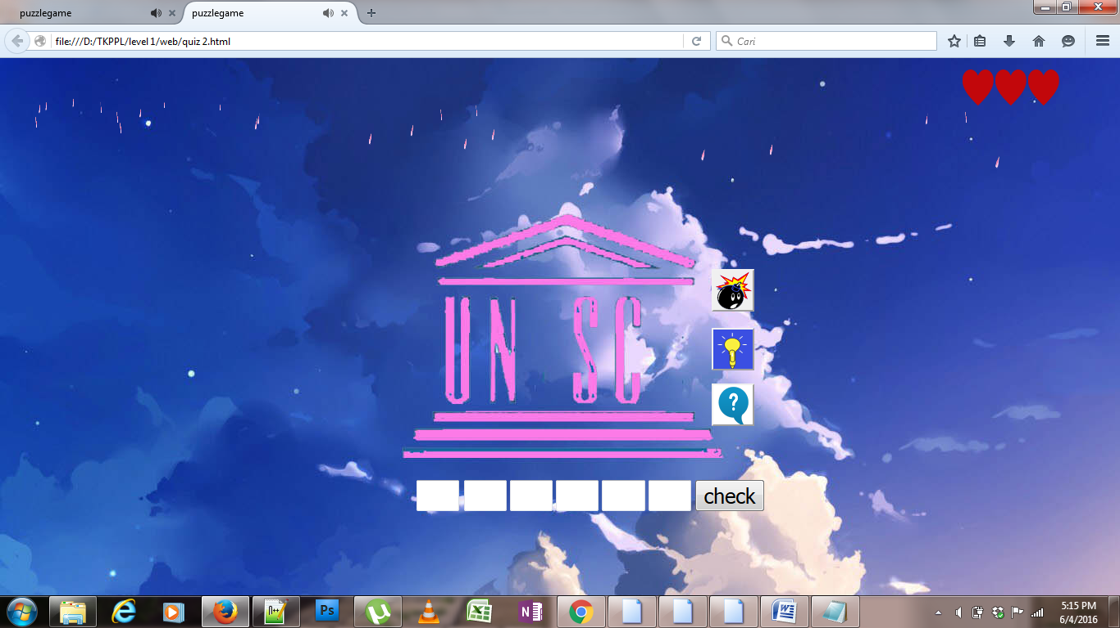

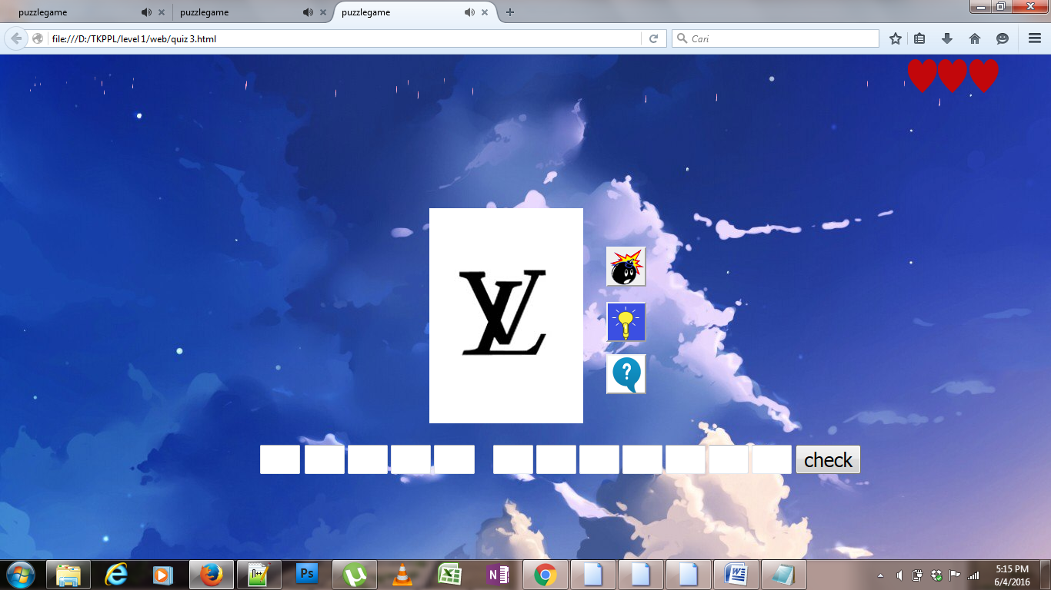

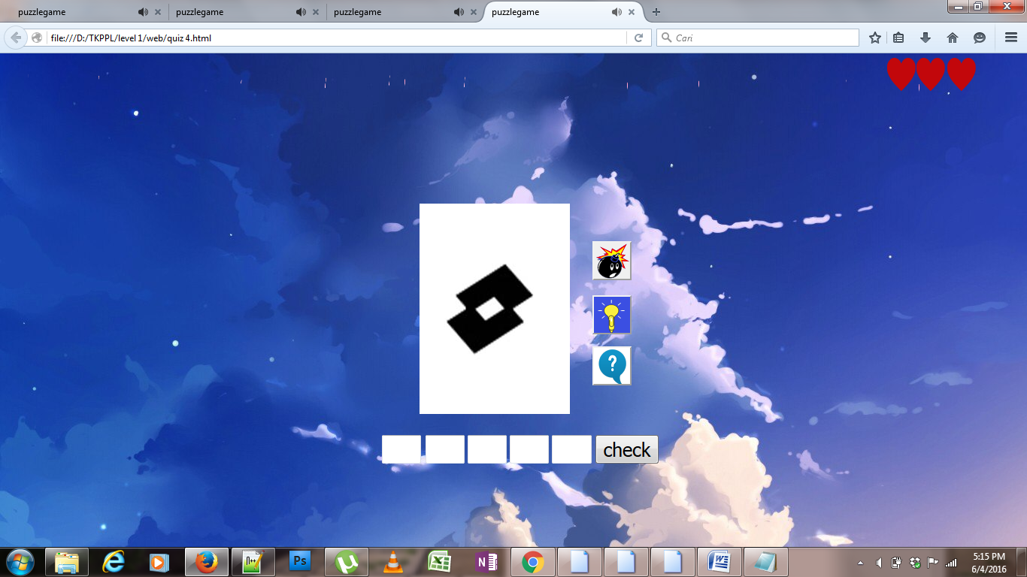

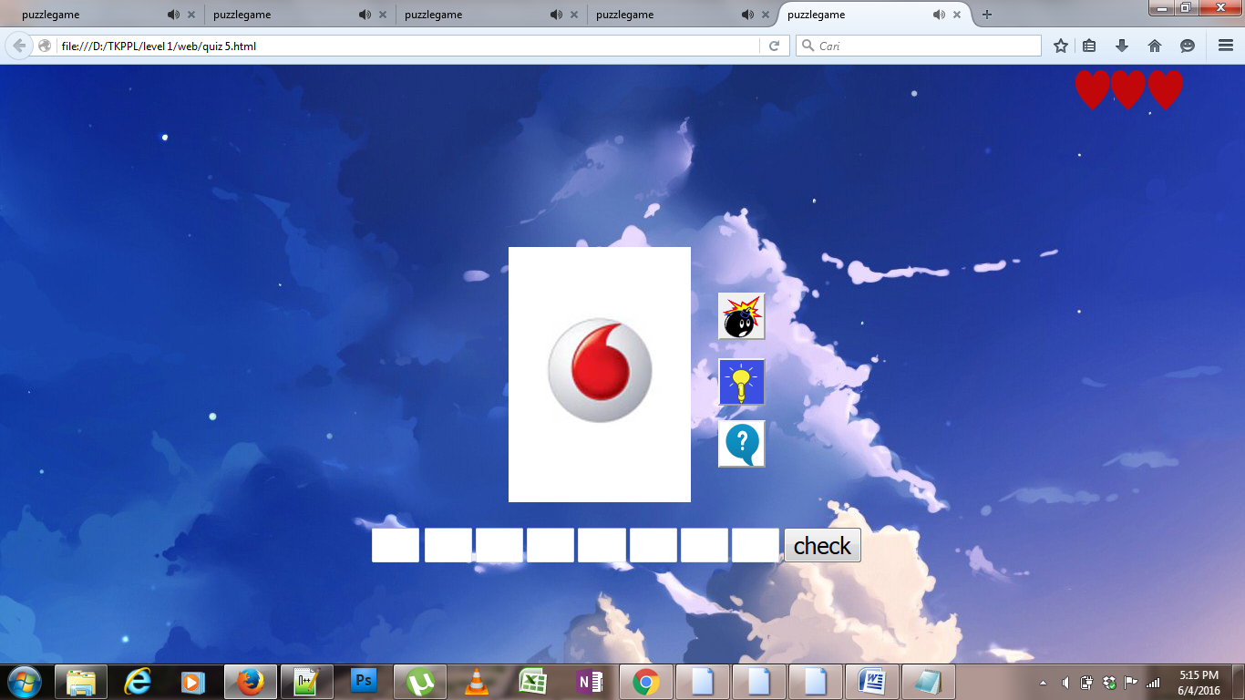

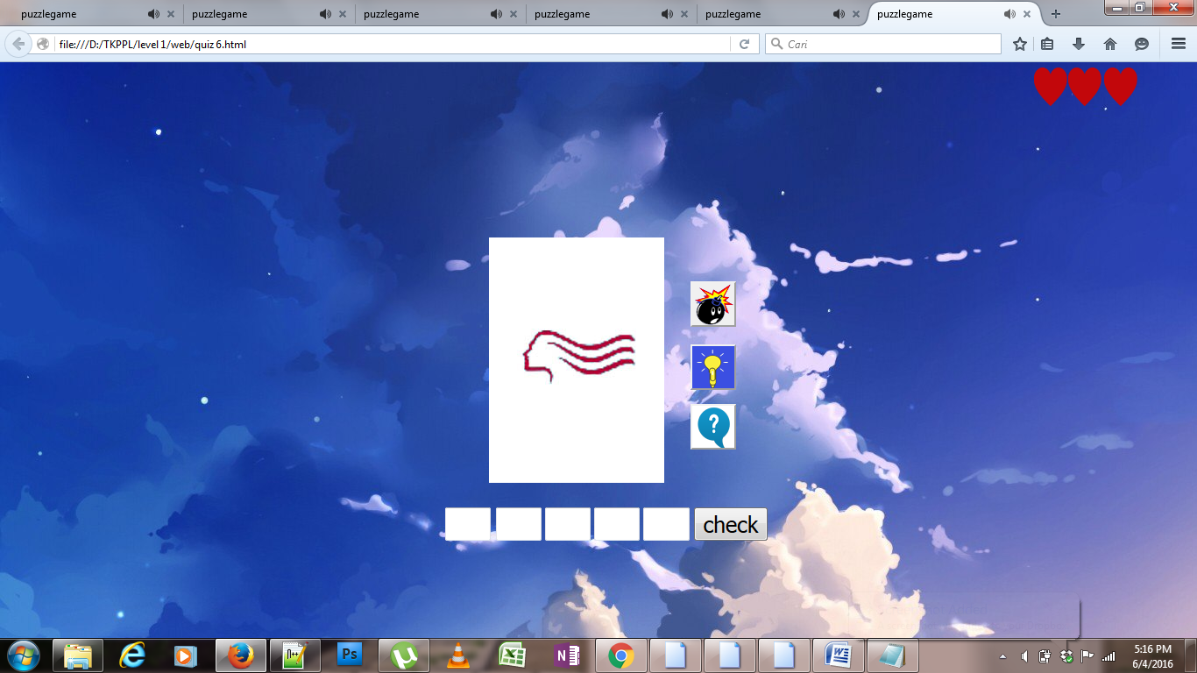

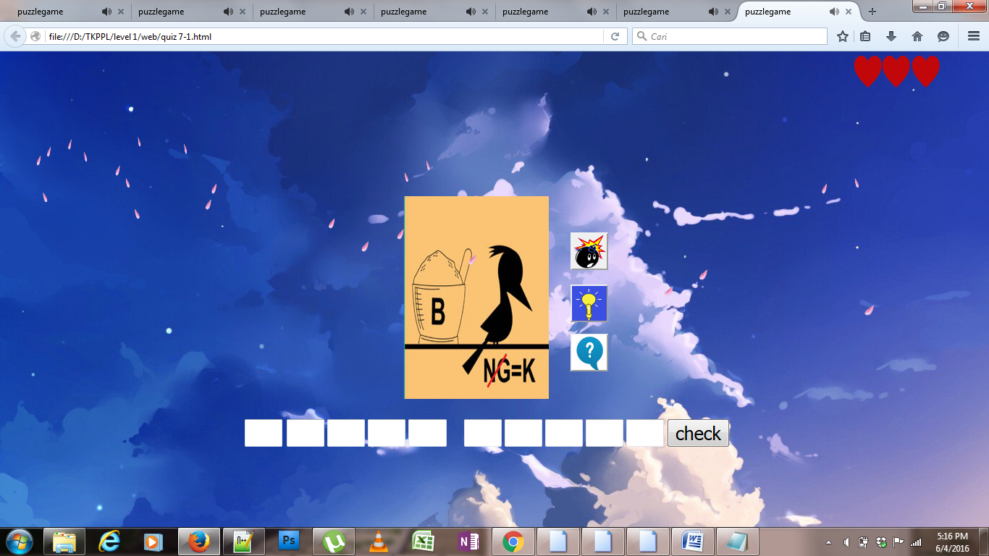

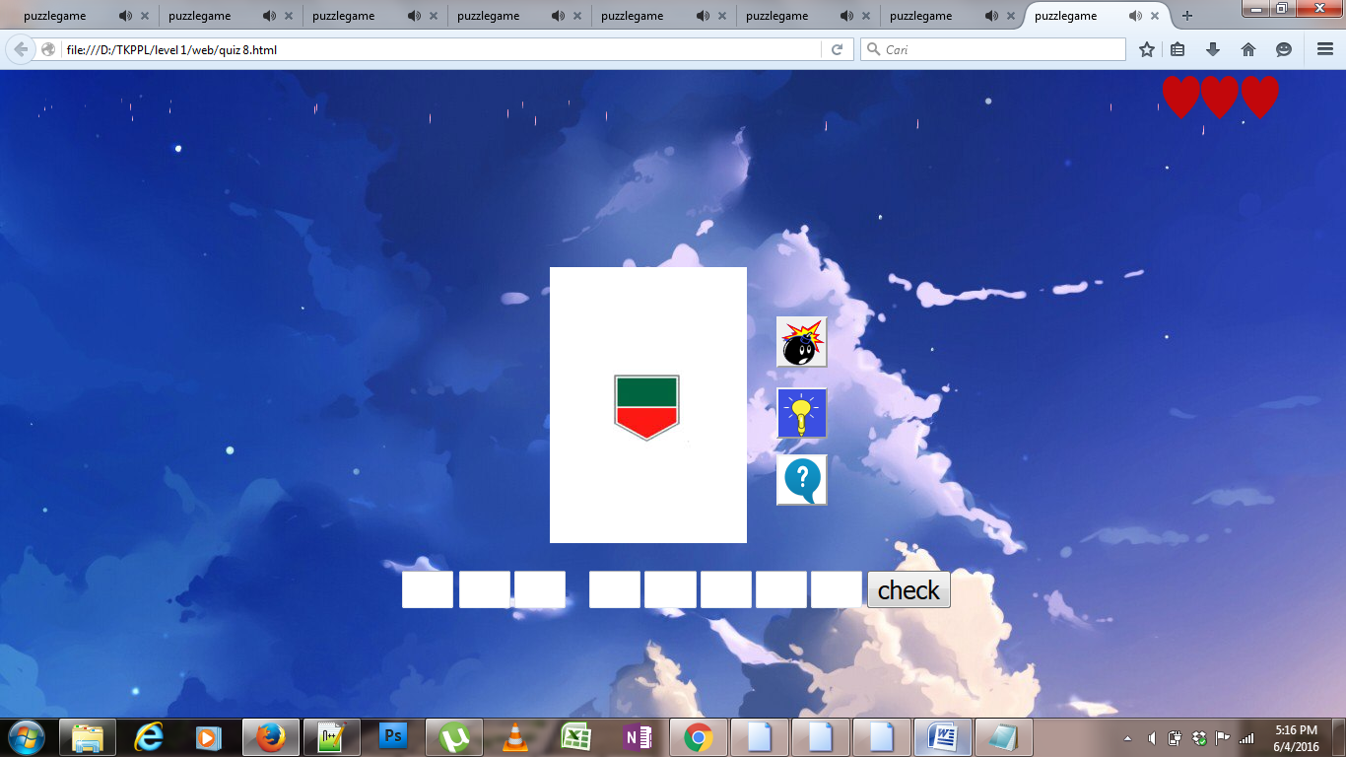

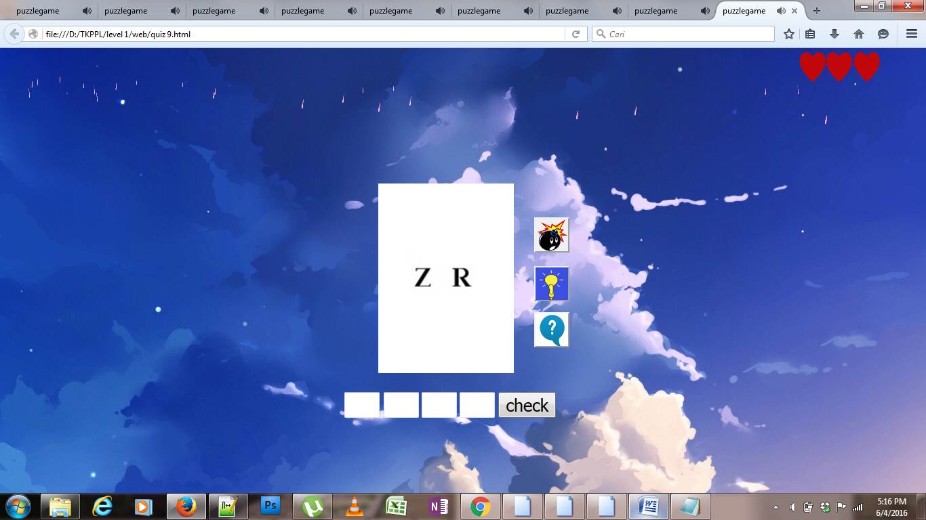

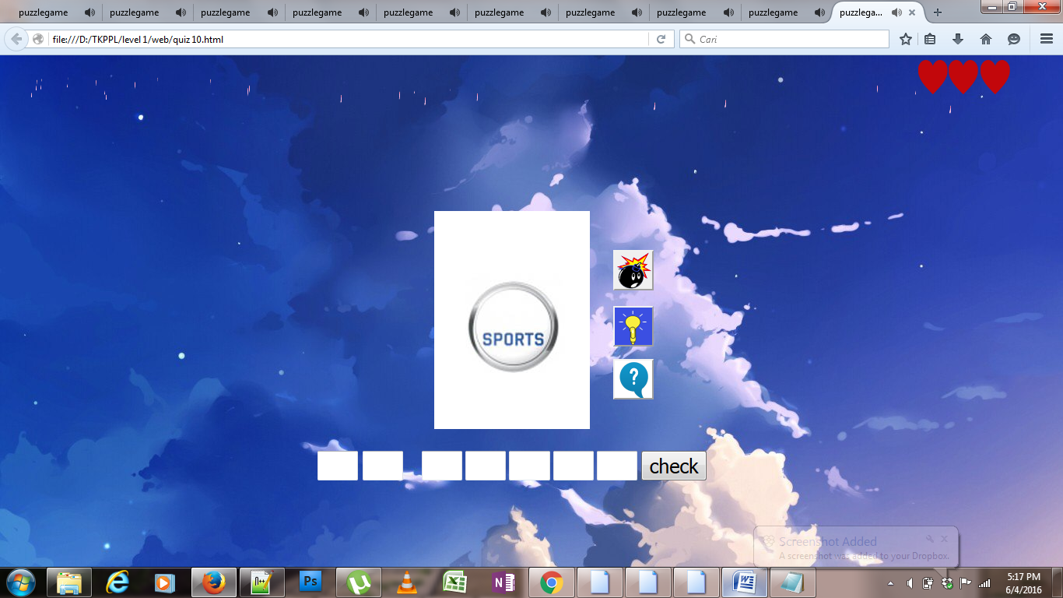berikut gambar diatas codenya semuanya sama ,hanya tinggal menggubah gambar saja ,dari code yang pertama